OHEYS Autism Programs
Registered Charity #86117-9083-RR0001

SUMMER DAY CAMPS:

MIDDLE YEARS CAMP (age 10-14)
JOBS & SPORTS TEEN CAMP (age 15-21)

Be a
Camp Coach

“Sharing Camp Fun with
Special Children in our Community”

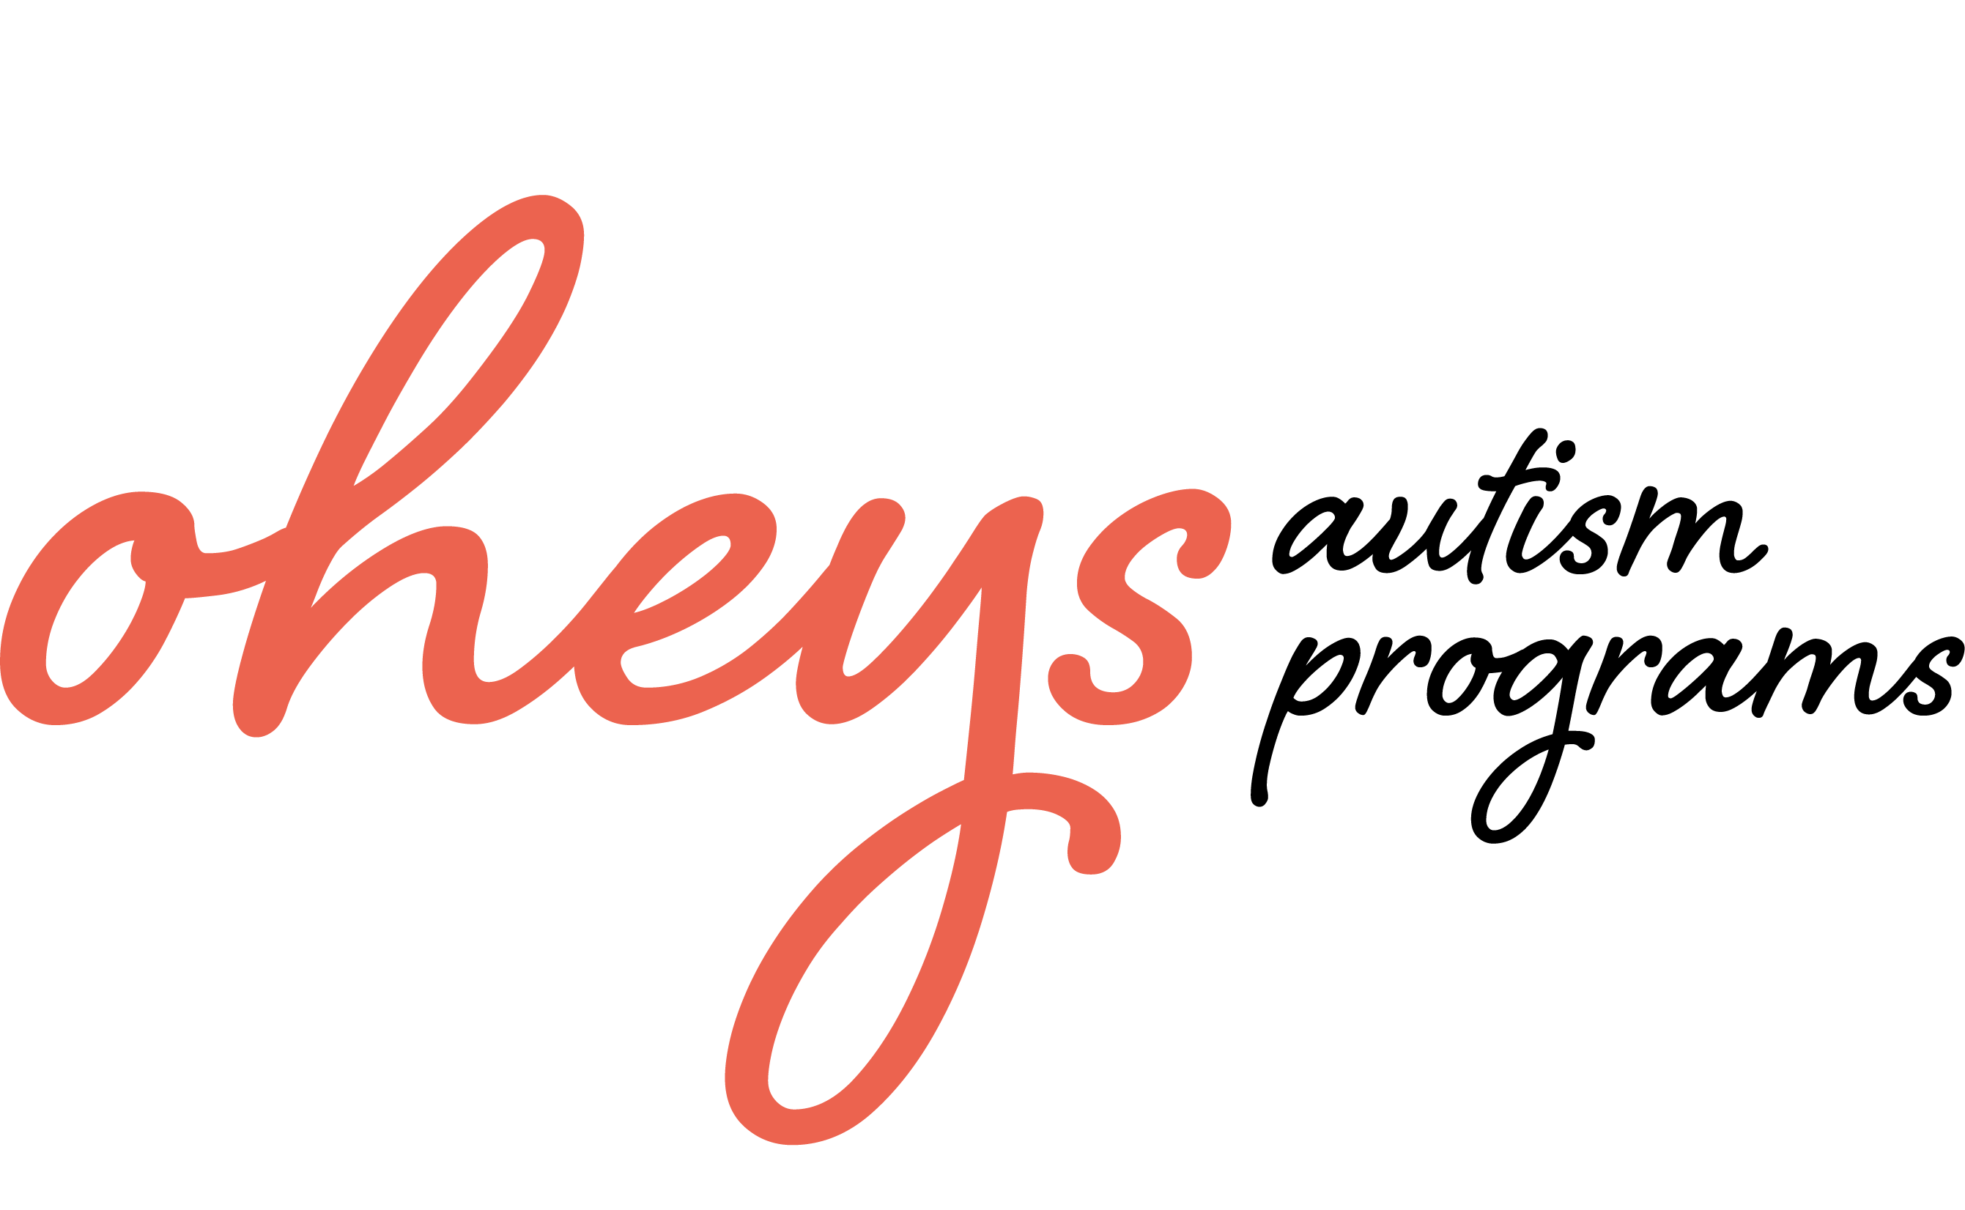

Contact: Bennetta Benson, Camp Director
61 Linacre Road, Winnipeg, Manitoba R3T 3G7
Tel: 204-275-1498 OHEYSAutismPrograms@gmail.com
www.OHEYS.org
OHEYS Autism Programs Summer Day Camps
Camp Coach Application

Specifically meeting the needs of school-aged children on the autism spectrum

We are looking for enthusiastic, active and qualified coaches for a local summer day camp. This position is ideal for you if your educational background is: inclusive/special education, adapted physical education, school psychology, Applied Behaviour Analysis, occupational therapy, speech/language or related academic areas AND have some prior hands-on experience working with youth on the spectrum. University students and school teachers or EA’s who are off for the summer, are ideal candidates. This is an excellent hands-on career-related experience for you in this field! Training is provided. You are hired as an independent contractor.

OHEYS offers two summer camp programs specifically for pre-teens to young adults on the autism spectrum. Our camp provides a unique opportunity for camp programming within the structure of a group setting. It includes coaches and supervisors with knowledge and training about autism and experience in working with youth at a variety of different developmental levels. Our focus is on encouraging physical activity and healthy lifestyles, and developing social skills and peer relationships. OHEYS Middle Years Adventure Camp includes fun activities such as Skyzone, archery, swimming and more! OHEYS “Jobs & Sports” is an adolescent activity based program, which addresses these two challenging areas: potential employment and lifelong physical activity. Participants get to choose work placements and work on employment skills, as well as fun field trips!

Week 1 - JOBS & SPORTS CAMP (age 15-21) Monday July 17 - Friday July 21 8:45 – 4:15pm

Week 2 - MIDDLE YEARS CAMP (age 10-14 verbal/similar skill levels) Monday July 24 - Friday July 28 8:45 – 4:15pm

Week 3 - JOBS & SPORTS CAMP (age 15-21) Monday July 31 - Friday Aug 4 8:45 – 4:15pm

Week 4 - JOBS & SPORTS CAMP (age 15-21) Monday Aug 14 - Friday Aug 18 8:45 – 4:15pm

One Camp Site Location – Fort Garry Mennonite Brethren Church, 1771 Pembina Hwy (close to UM)

THE JOB
20 children on the autism spectrum attend for the week. Children are accepted based on ability to participate, so campers vary from children with behaviour/language challenges to children who are working on more advanced physical, social and language goals. Coaches work under the supervision of on-site Camp Directors experienced in behaviour modification principles and practices.

Coaches – You will work on social skills, physical skills, general camp-type activity experiences, and verbal interactions. Activity schedules and token boards may used, as appropriate. Prior to camp, Camp Directors meet with participant families specifically to set out goals and objectives for a successful experience for each child. These meetings are held between March-May. The coaches training session will be held May-June (TBA) where child-specific goals and the camp program will be discussed in detail.

BREAKDOWN OF HOURS
You should be able to work the full week you sign up for AND be available for orientation/planning in preparation for the camp weeks. On-site camp hours start at $12.50/hour. Training time is required, and is paid. Optional equipment set-up and tear down time (if you are available) is also $11.00/hr. You are paid as an independent contractor. Objectives during the paid lunch time at camp are assisting children with appropriate food selection, table manners and conversation with peers. Lunch is provided for coaches.

Please forward a resume or other supporting documentation as applicable and available.

Call or email with any questions.

Bennetta Benson, Program Director tel: 204-275-1498 OHEYSAutismPrograms@gmail.com
OHEYS Summer Camp, 61 Linacre Road, Wpg, MB R3T 3G7 www.OHEYS.org

Coach Application 2017

OHEYS AUTISM PROGRAMS SUMMER DAY CAMPS
Winnipeg Optimal Health Early Years Sports Club - Registered Charity #986117 9083 RR0001

Name (print clearly): ____________________________________________________________________________

Address: _______________________________________________________ P/Code: _______________________

Tel (h):__________________(cell)__________________email: __________________________________________

Program Dates:

Week 1 ____ JOBS & SPORTS CAMP (age 15-21) Monday July 17 - Friday July 21 8:45 – 4:15pm

Week 2 ____ MIDDLE YEARS CAMP (age 10-14 verbal/similar skill levels) Monday July 24 - Friday July 28 8:45 – 4:15pm

Week 3 ____ JOBS & SPORTS CAMP (age 15-21) Monday July 31 - Friday Aug 4 8:45 – 4:15pm

Week 4 ____ JOBS & SPORTS CAMP (age 15-21) Monday Aug 14 - Friday Aug 18 8:45 – 4:15pm

Training Date: late May-June 2-4 TBA after family interviews have been completed; Equipment set-up/tear-down if available.

1) I have prior experience working with children with autism: _____ yes, a lot _____yes, a little _____ no
In what capacity? __________________________________________________________________________________________________
2) I have experience OR training in Applied Behaviour Analysis (ABA) or behaviour modification:
_____ yes _____ no Please describe: __________________________________________________________________________________________________
3) I have prior experience working with children: _____ yes, a lot _____yes, a little _____ no
In what capacity?
__________________________________________________________________________________________________

__________________________________________________________________________________________________
4) Please describe any other education or work/volunteer training and experience you bring to this position:

__________________________________________________________________________________________________

__________________________________________________________________________________________________

__________________________________________________________________________________________________
Please forward a resume or other supporting documentation as applicable and available.

Scan & email OR mail application form to:
Bennetta Benson, Program Director tel: 204-275-1498 OHEYSAutismPrograms@gmail.com
OHEYS Summer Camp, 61 Linacre Road, Wpg, MB R3T 3G7 www.OHEYS.org

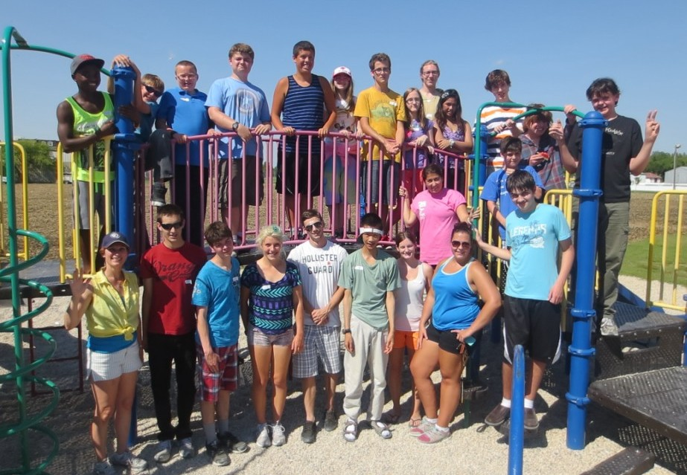

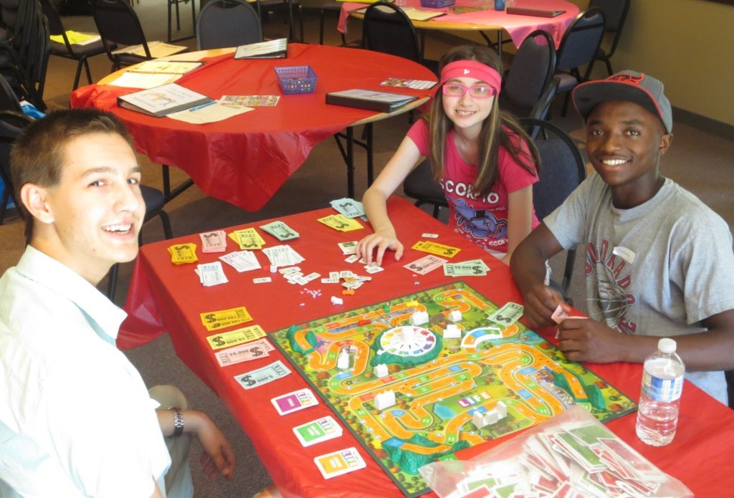

g

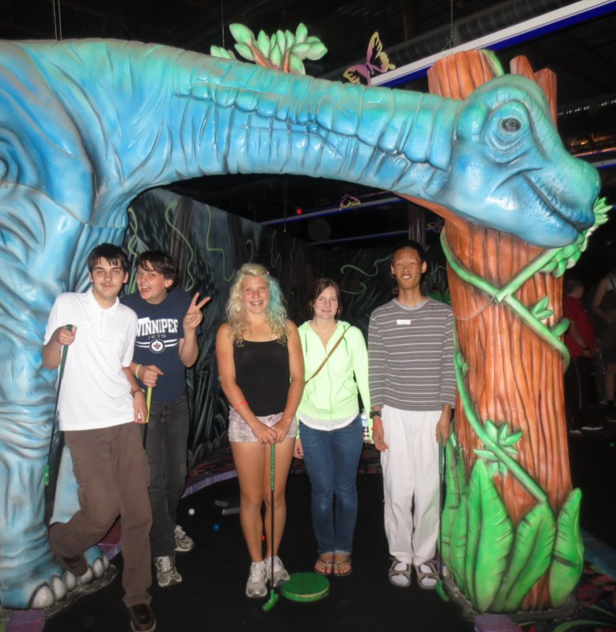


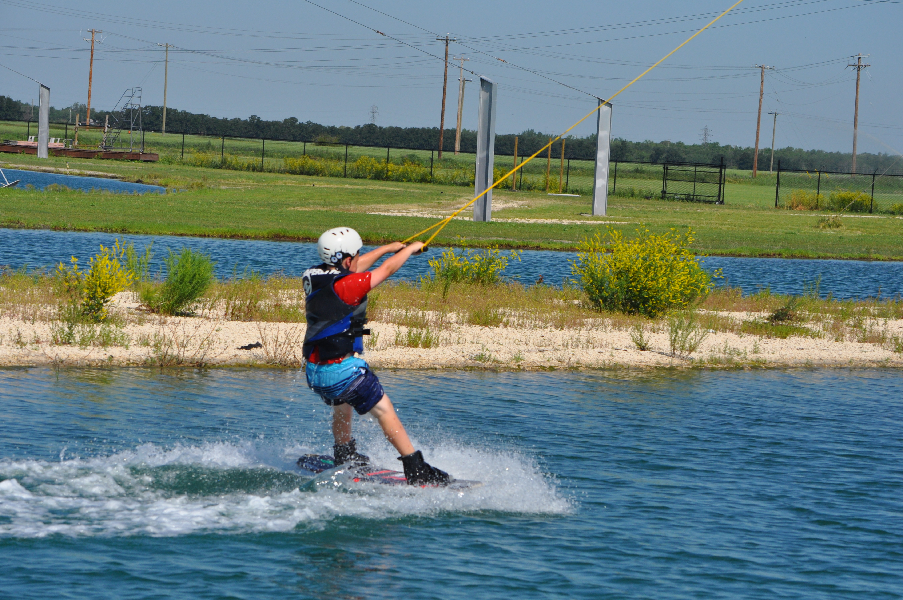

“Congratulations... to OHEYS Autism Programs for being named recipient of the Mayor’s Volunteer Service Award for providing physical activity programming for children with autism. Volunteerism is the very foundation of sports delivery in Manitoba.

It is because of organizations such as yours, and the contributions you have made to sport development, that we have a thriving sport delivery system in the province. A strong sport delivery system makes for stronger communities.”
Jeff Hnatiuk, President and CEO
SPORT MANITOBA



